Bio Inspired Systems

**Summary of Algorithms:**

**1. Genetic Algorithm:**

GA works on a population consisting of some solutions where the population size (popsize) is the number of solutions. Each solution is called individual. Each individual solution has a chromosome. The chromosome is represented as a set of parameters (features) that defines the individual. Each chromosome has a set of genes. Each gene is represented by somehow such as being represented as a string of 0s and 1s as shown in figure.

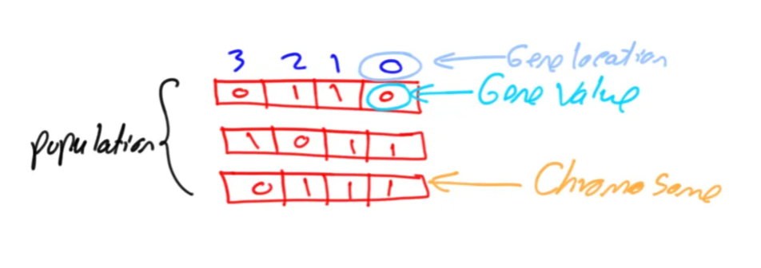

Also, each individual has a fitness value. To select the best individuals, a fitness function is used. The result of the fitness function is the fitness value representing the quality of the solution. The higher the fitness value the higher the quality the solution. Selection of the best individuals based on their quality is applied to generate what is called a mating pool where the higher quality individual has higher probability of being selected in the mating pool.

**Uses:**

* **Search and Optimization**: GAs are primarily used to search for optimal or near-optimal solutions in large and complex solution spaces.
* **Adaptation and Learning**: They can adapt solutions based on evolving criteria or changing environments.
* **Simulation of Evolutionary Processes**: GAs model natural selection to evolve solutions over generations.

**Applications:**

* **Engineering Design**:

Structural Optimization: Designing structures that maximize strength while minimizing material use.

* **Circuit Design**: Optimizing electronic circuits for performance and efficiency.
* **Machine Learning**:

Feature Selection: Identifying the most relevant features for improving model accuracy.

Hyperparameter Tuning: Optimizing the parameters of machine learning algorithms.

**Optimization techniques**:

To further optimize genetic algorithms (GAs), you can explore several advanced techniques and strategies. Here’s a breakdown of how to enhance GAs for better performance:

* **Diversity Maintenance Techniques**

**Crowding**: Limit the number of similar individuals in the population to avoid premature convergence.

**Niche Formation**: Encourage the emergence of diverse subpopulations to explore different regions of the solution space.

### ****Parallel and Distributed Approaches****

**Island Models**: Divide the population into subpopulations that evolve independently, with occasional migration of individuals.

**Master-Slave Models**: Utilize multiple processors for fitness evaluations and genetic operations, speeding up the process**.**

* **Hybrid Approaches**

**Combine with Local Search**: Integrate local search methods (e.g., hill climbing, simulated annealing) after genetic operations to refine solutions.

**Use Other Metaheuristics**: Combine GAs with other algorithms, like Particle Swarm Optimization (PSO) or Ant Colony Optimization (ACO), to leverage their strengths.

**2. Particle Swarm Optimization (PSO)**

It is a computational method inspired by the social behavior of birds and fish. It’s used to find optimal solutions in multidimensional spaces by simulating a group of particles (potential solutions) that move through the search space based on their own experiences and those of their neighbors.

Key Components

* Particles: Each particle represents a potential solution with a position and velocity in the search space.
* Personal Best (pBest): Each particle keeps track of its best-known position.
* Global Best (gBest): The best position found by any particle in the swarm.
* Velocity Update: Particles adjust their velocities based on their pBest and gBest, allowing them to explore the space.

### Uses of PSO

1. **Optimization**: PSO is primarily used to find optimal or near-optimal solutions for complex functions.
2. **Function Approximation**: It helps in approximating functions that may be difficult to model mathematically.
3. **Parameter Tuning**: PSO is utilized for tuning hyperparameters in machine learning models.

**Applications**

1. **Engineering Design**:
   * Structural optimization and design of mechanical components.
2. **Robotics**:
   * Path planning and navigation of robots in dynamic environments.
3. **Finance**:
   * Portfolio optimization and risk management strategies.
4. **Neural Networks**:
   * Optimizing weights and architecture of neural networks.
5. **Image Processing**:
   * Feature selection and image segmentation tasks.

**Optimization techniques:**

1. Hybrid Approaches:

* Combine PSO with other algorithms (e.g., genetic algorithms, simulated annealing) to enhance exploration and exploitation.

2. Adaptive PSO:

* Adjust the inertia weight, cognitive, and social components dynamically based on performance during iterations.

3. Multi-Swarm Techniques:

* Use multiple swarms with different strategies to explore various regions of the search space concurrently.

4. Velocity Clamping:

* Limit particle velocities to avoid overshooting the optimal region, improving convergence speed.

**3. Ant Colony Optimization (ACO)**

Ant Colony Optimization is inspired by the foraging behaviour of ants. Ants deposit pheromones on paths they traverse, influencing the choices of other ants. Over time, shorter paths accumulate more pheromone, guiding the swarm towards optimal solutions. It is particularly effective for discrete optimization problems and has been adapted to various domains.

*Uses:* Primarily utilized for combinatorial optimization problems such as the Traveling Salesman Problem, vehicle routing, and scheduling.

*Application Fields:* Commonly applied in telecommunications for network design, transportation logistics, and even in bioinformatics for DNA sequencing.

*Optimization Techniques:*

* Pheromone Evaporation Rates: Helps prevent stagnation by reducing pheromone influence over time.
* Heuristic Information Integration: Combines pheromone trails with heuristic data to enhance decision-making.
* Adaptive Parameter Tuning: Dynamically adjusts parameters based on search progress and performance.

**4. Cuckoo Search (CS)**

Cuckoo Search is a metaheuristic inspired by the brood parasitism of some cuckoo species, where they lay their eggs in the nests of other birds. This algorithm employs Levy flights (random walks) to explore the search space and replaces the least fit solutions with new ones. It is particularly suitable for global optimization problems.

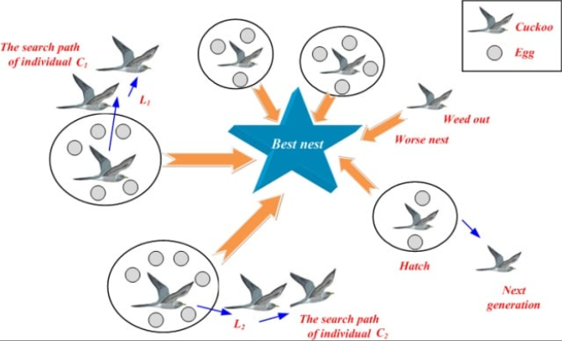

*Uses:* Effective in solving complex optimization problems, especially those with many local optima.

*Application Fields:* Applied in engineering design, finance for portfolio optimization, and structural optimization in civil engineering.

*Optimization Techniques:*

* Hybridization with Other Algorithms: Combines CS with GAs or PSO for enhanced performance.
* Adaptive Mutation Strategies: Adjusts the step size based on the search stage to balance exploration and exploitation.
* Dynamic Parameter Adjustment: Modifies parameters during the search based on performance feedback.

**5. Grey Wolf Optimizer (GWO)**

The Grey Wolf Optimizer simulates the social hierarchy and hunting behaviour of grey wolves. Wolves are classified into different roles (alpha, beta, delta, omega) that influence their search behaviour. It utilizes a balance of exploration and exploitation, guiding the search towards optimal solutions through a structured approach.

*Uses:* Suitable for continuous optimization problems and multi-objective optimization.

*Application Fields:* Used in machine learning for model optimization, image processing, and engineering problems.

*Optimization Techniques:*

* Dynamic Adjustment of Parameters: Adapts parameters like alpha, beta, and delta coefficients during the search process.
* Hybridization with Other Techniques: Combines GWO with other optimization algorithms to leverage their strengths.
* Multi-Objective Optimization: Extensions exist to handle multiple conflicting objectives simultaneously.

**6 Parallel Cellular Algorithms**

Parallel Cellular Algorithms operate on a grid or lattice structure where each cell represents a candidate solution. Cells evolve based on local interactions with their neighbours, allowing for a decentralized search process. This structure facilitates exploration of the solution space and is particularly effective for large-scale problems.

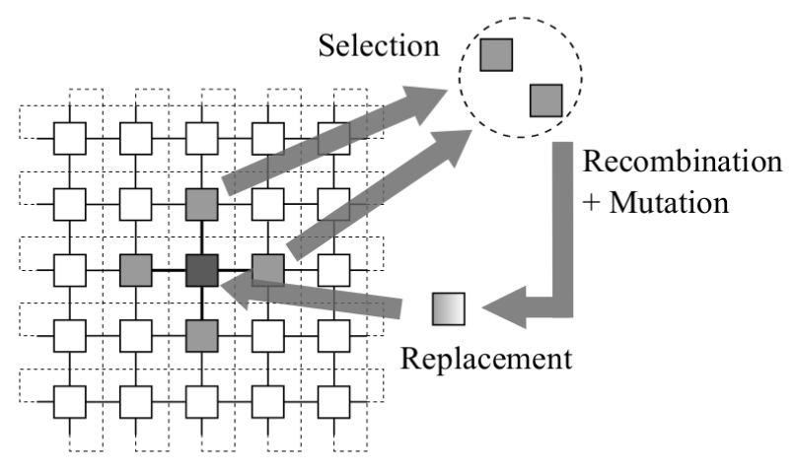

*Uses:* Suitable for optimization problems, especially those with high-dimensional search spaces.

*Application Fields:* Applied in image processing, optimization in computational biology, and simulations in physics and engineering.

*Optimization Techniques:*

* Asynchronous Updates: Cells can update independently, leading to potentially faster convergence.
* Adaptive Cell Structures: Allows dynamic changes in cell configurations based on the problem.
* Hybrid Methods: Combines with evolutionary algorithms to enhance solution quality.

**7. Gene Expression Algorithm (GEA)**

Gene Expression Algorithms are inspired by gene expression programming, where solutions are represented as genes that can undergo mutations and combinations. This algorithm evolves candidate solutions by interpreting genetic structures, enabling complex problem solving.

*Uses:* Effective for symbolic regression, function optimization, and machine learning applications.

*Application Fields*: Commonly utilized in bioinformatics, algorithm design, artificial intelligence, and predictive modelling.

*Optimization Techniques:*

* Gene Mutation Control: Regulates the extent of mutation to maintain diversity while ensuring convergence.
* Selective Breeding: Enhances the quality of offspring solutions based on fitness criteria.
* Hybrid Approaches: Integrates GEA with other evolutionary strategies for improved performance.